**IE Browser Issues**

1. In Dashboard on pagination double click it will show white space under table.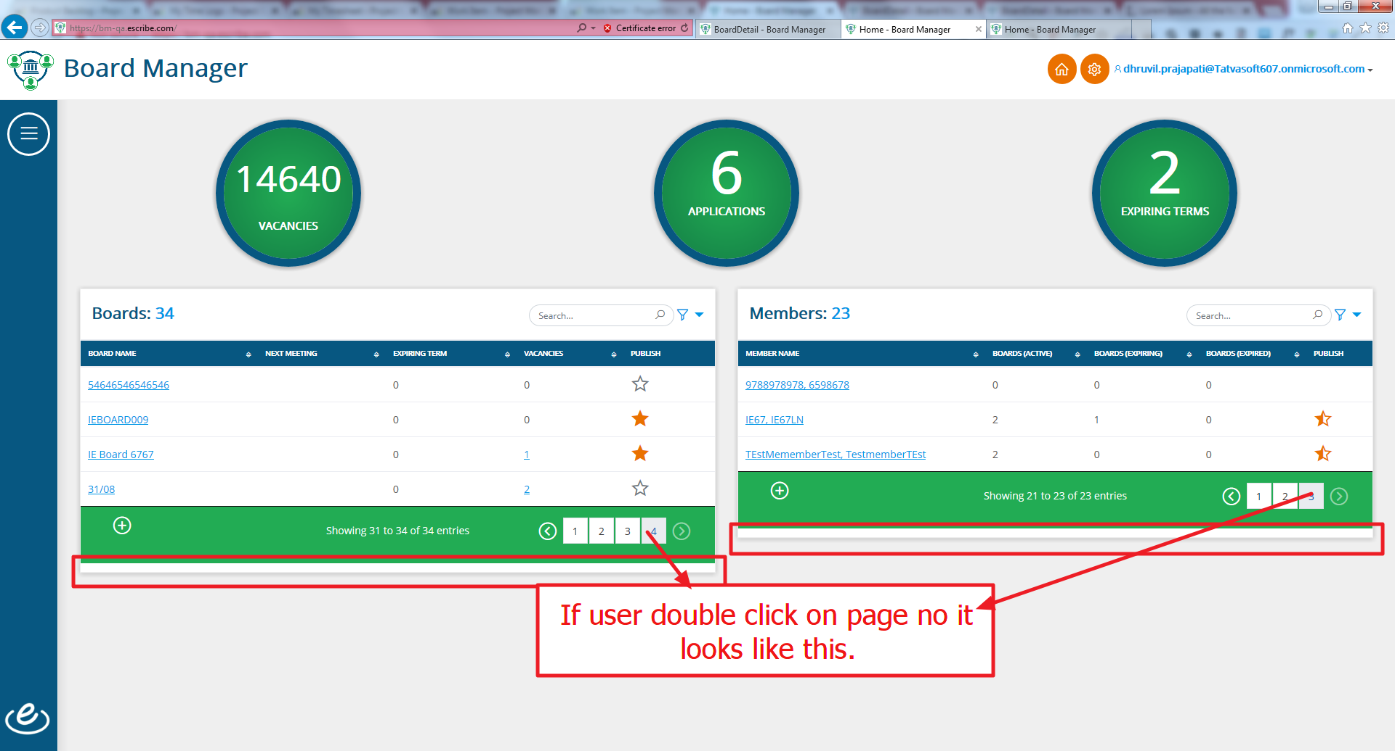
2. In member detail page while “Add Term” and “Edit Term” start term date and end term date text shows as red.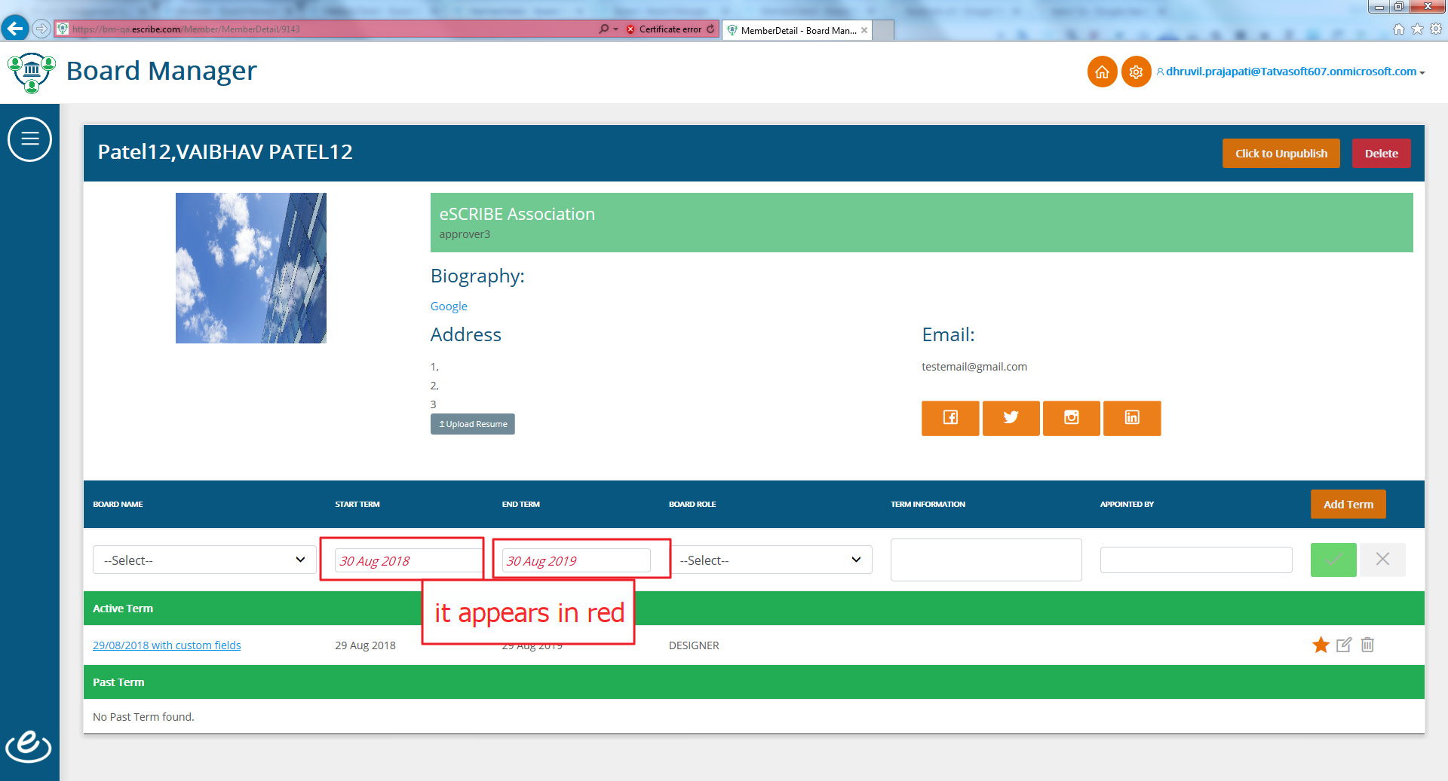
3. In board detail page spinner is not display for numeric fields and show 2 clear icons.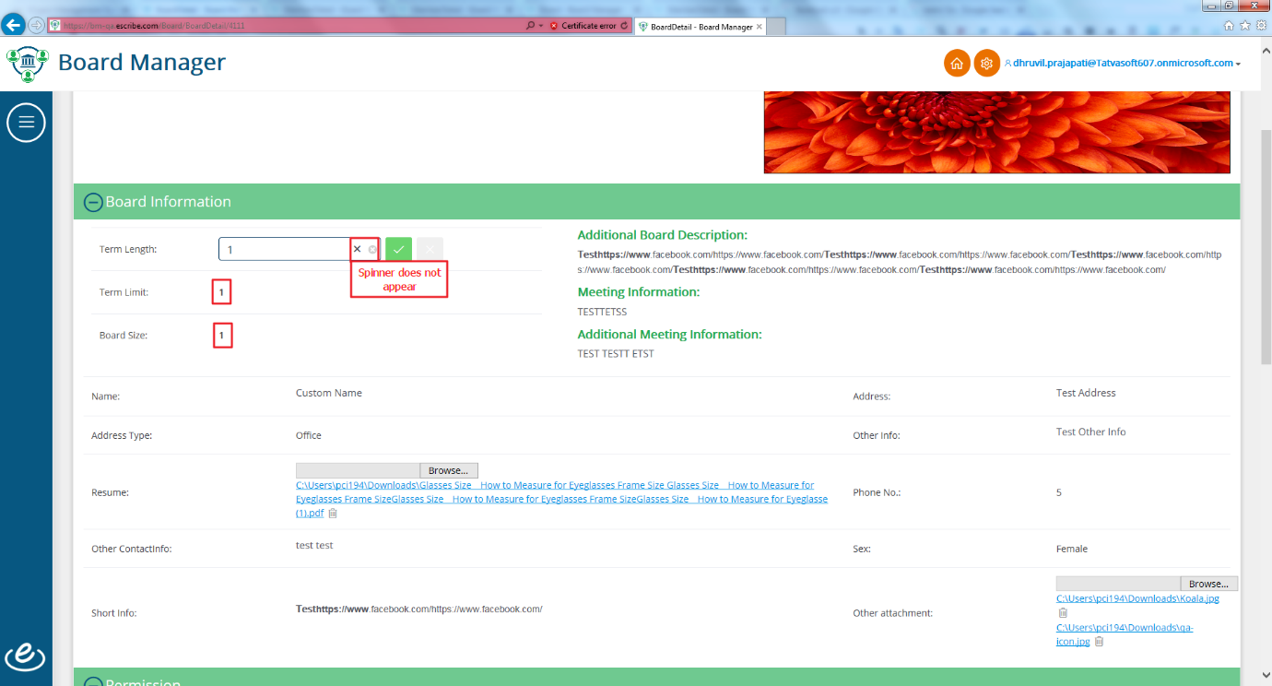
4. In candidate popup filter will be shown in same line.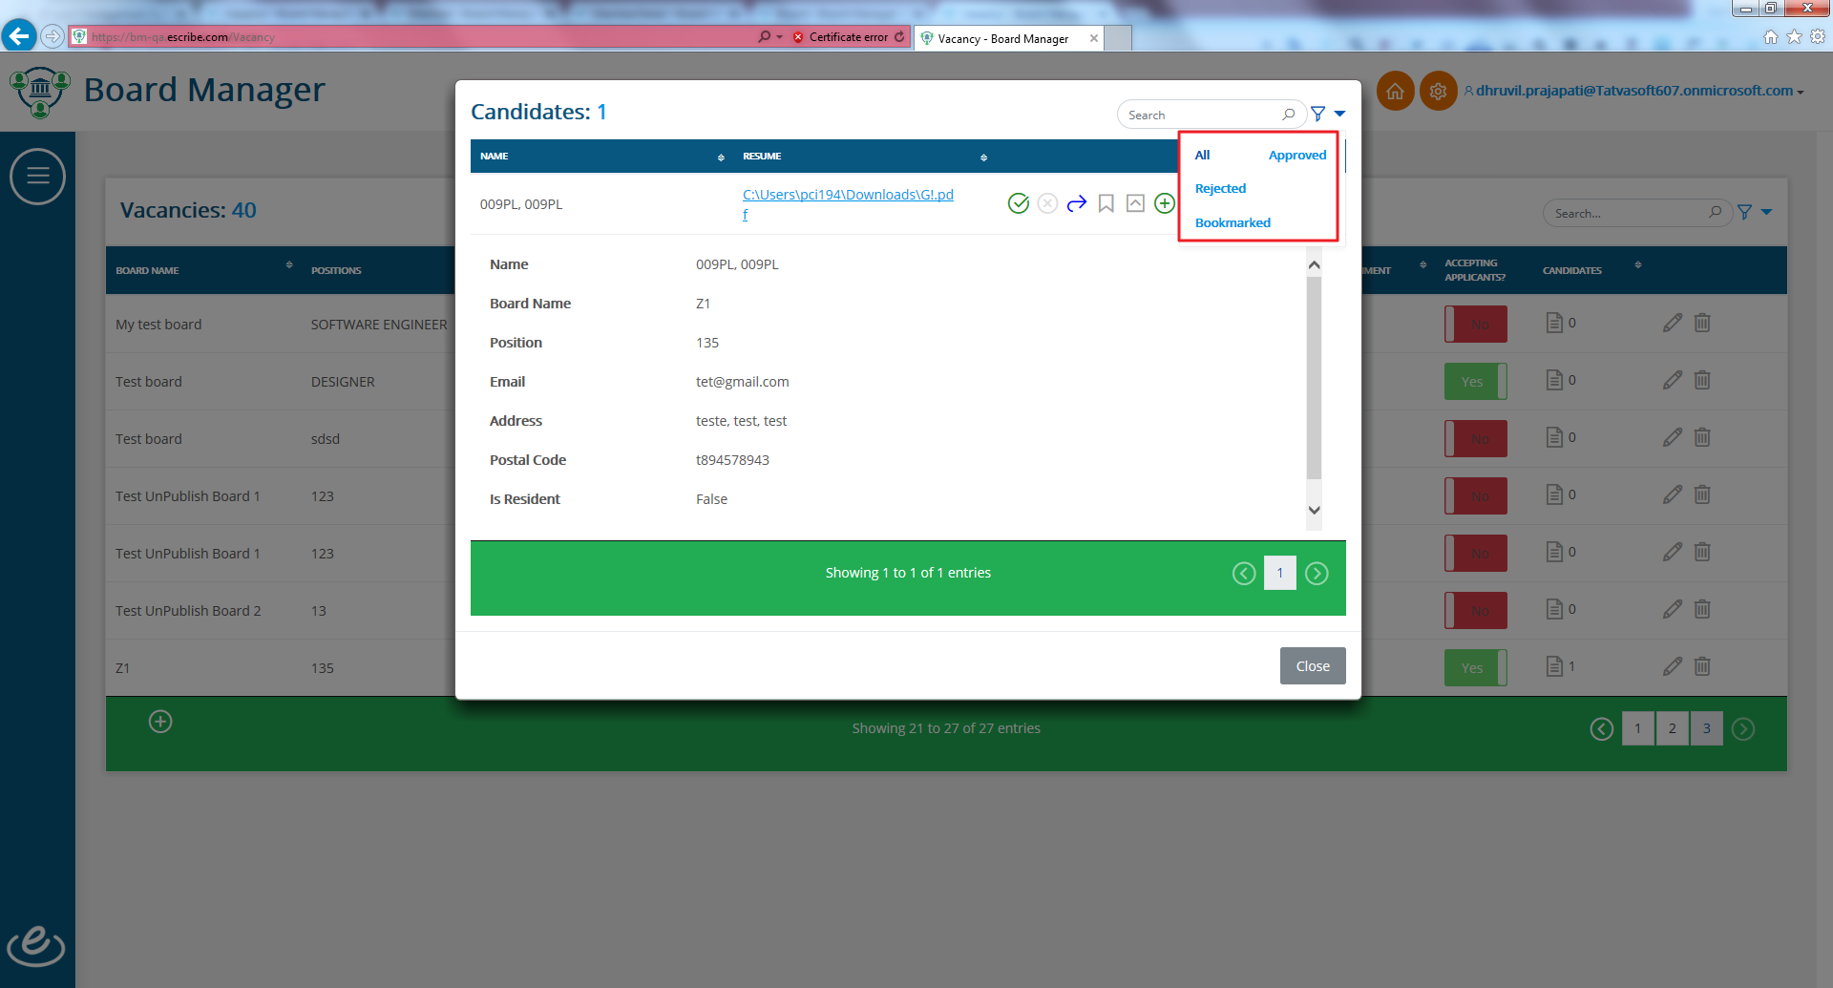
5. While add new vacancy spinner doesn’t display.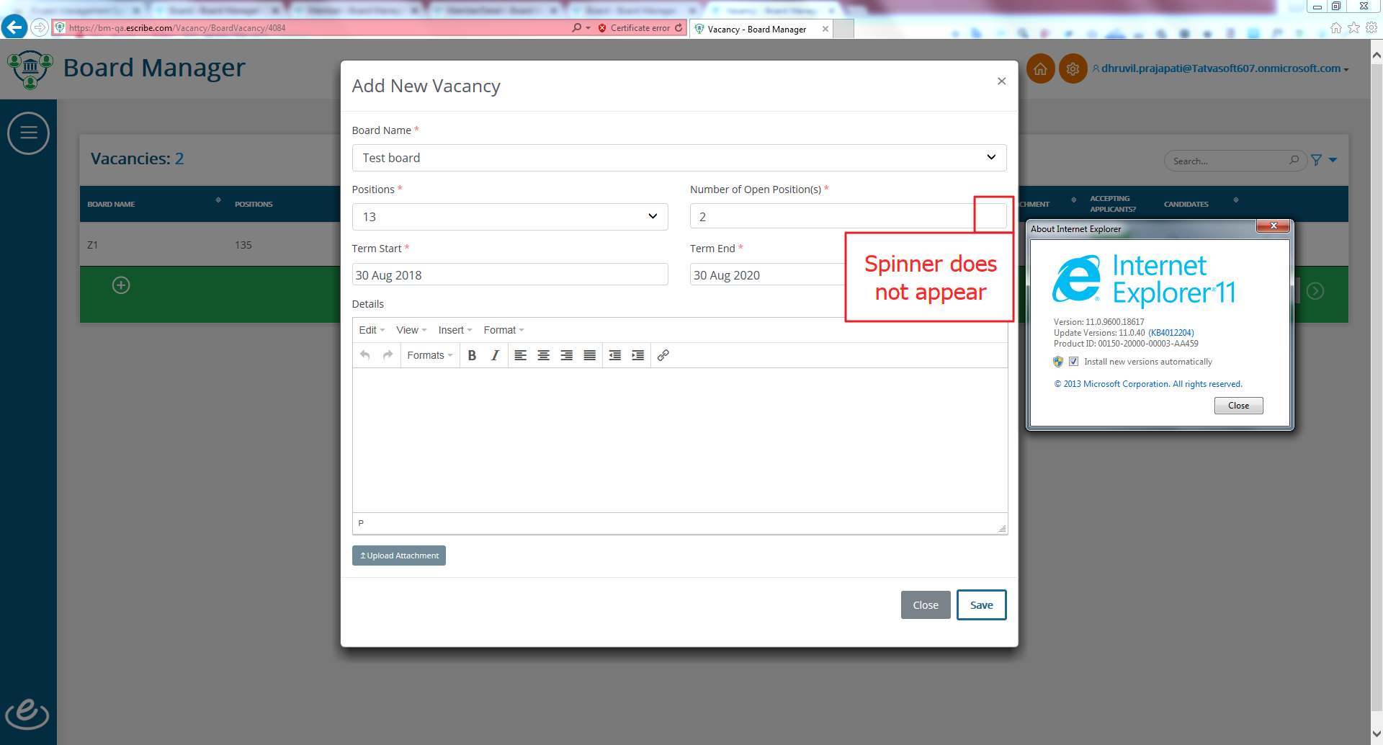
6. In public site dashboard search text box design looks poor.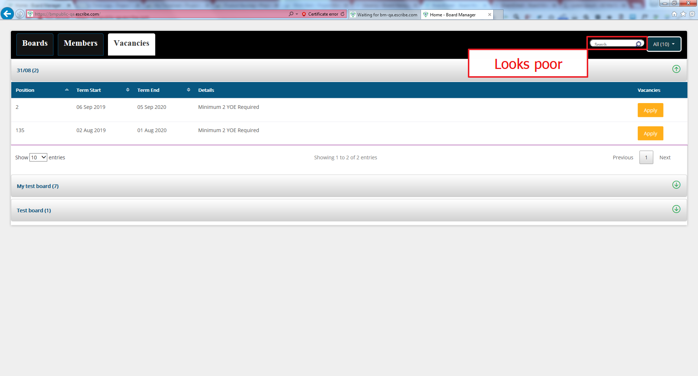
7. In apply vacancy form for “Resident” column radio button is not display.